**User Login and Registration:**

Step:1-Open Anyscrap Webapplication

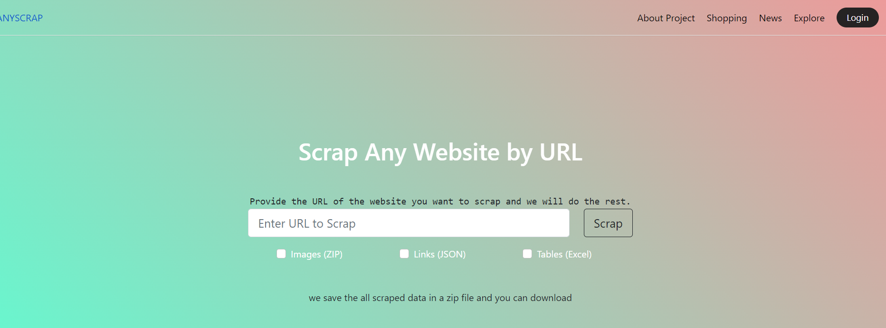

Step-2- Click on Login button.

Step:3-Click on Sign Up.

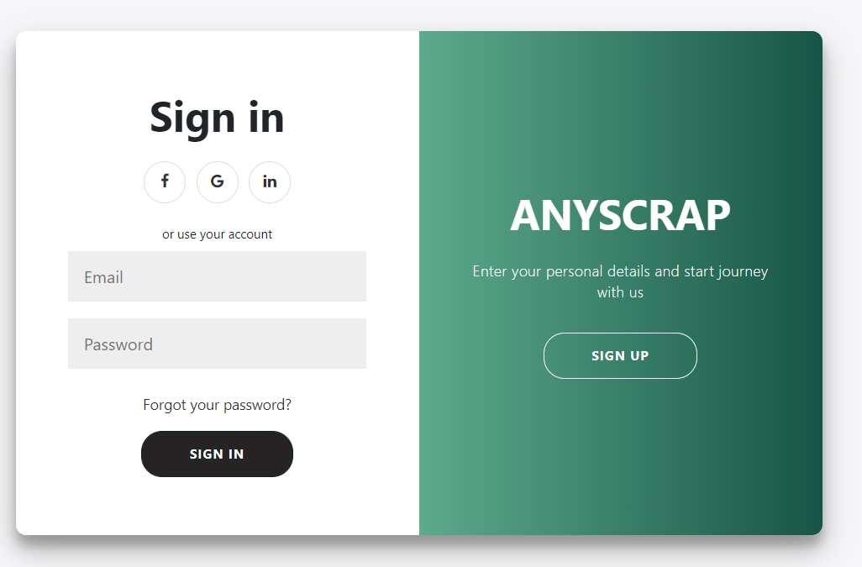

Step:4:Enter your name, email and password.

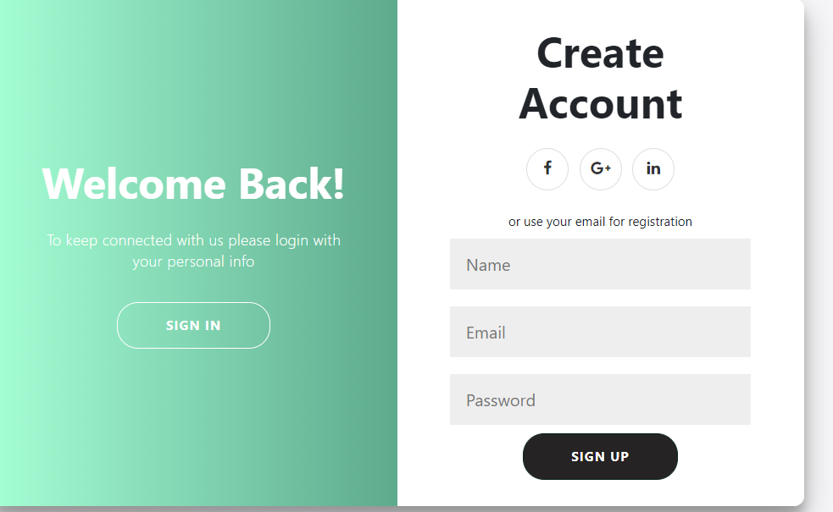

If you are already signed up

Step:1-Enter email and password by which you have registered.



Step:2-Click on Sign in.

**For Scrapping Data From a link**

Enter the link of the page you want to scrap and choose image,link or tables you want to scrap

And then click on scrap



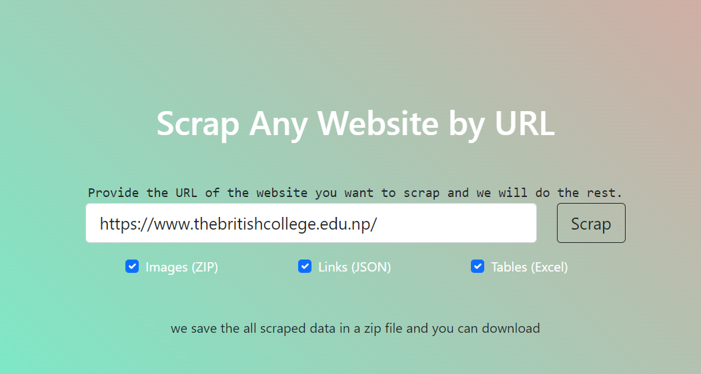

After clicking on scrap , you will get a download option, click on download to download the scrapped file.

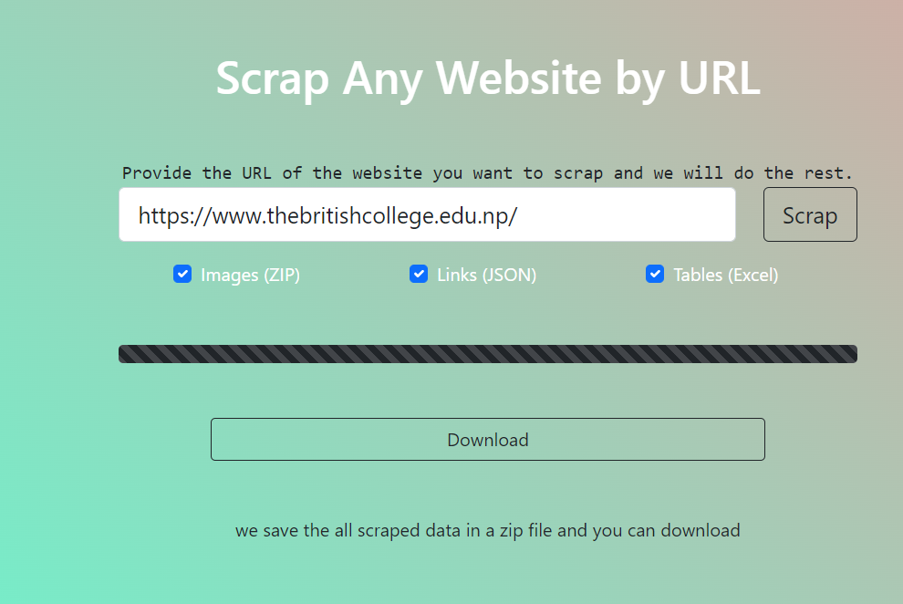

**For comparing products from Ebay, amazon and snapdeal , click on shopping**



After clicking on shopping, you will be redirected to ecommerce page

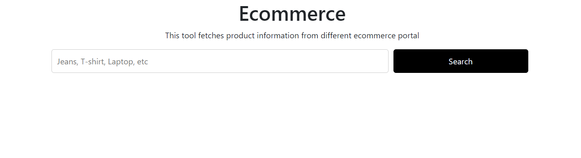

Type the name of the product and click on search.

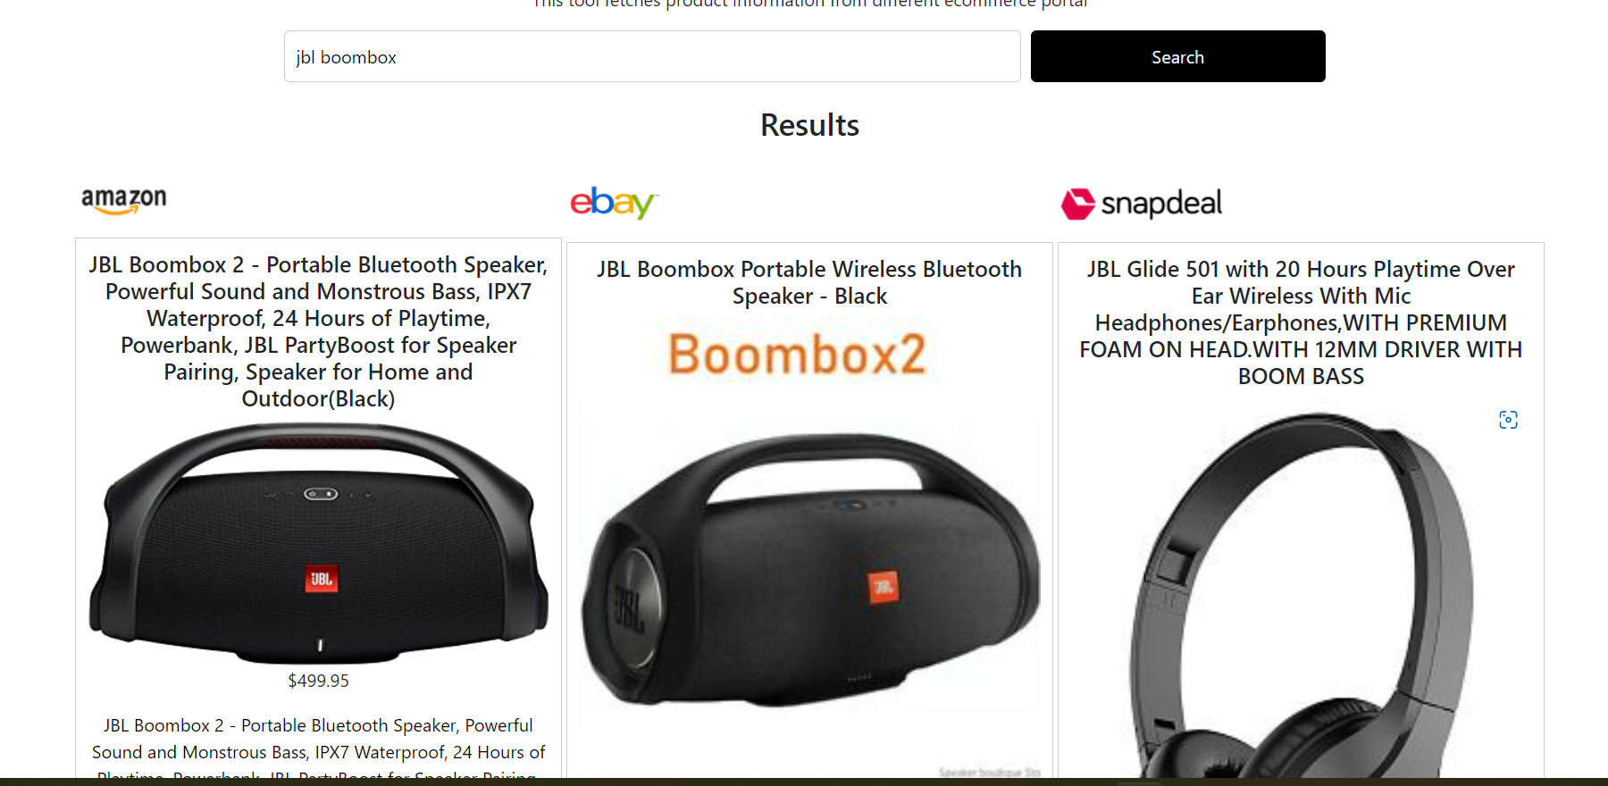

**Click on News to view News from Online Khabar, BBC and The New York Times**.



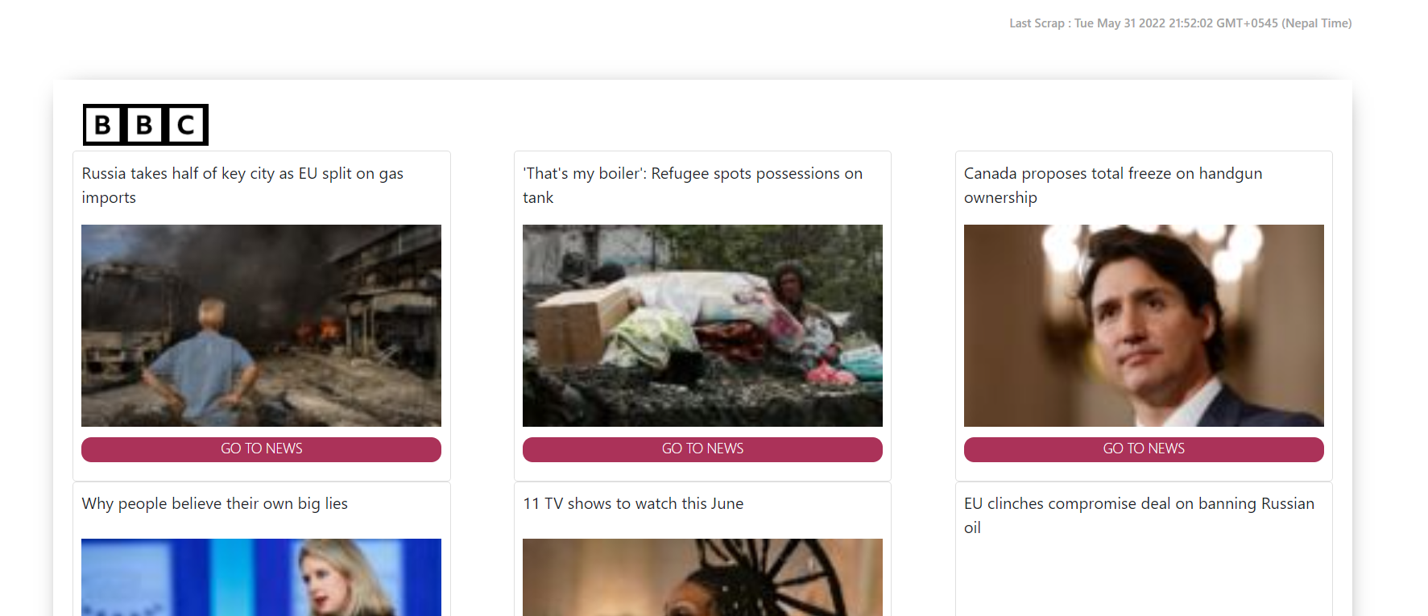

**Click on Explore to view Public API’s**



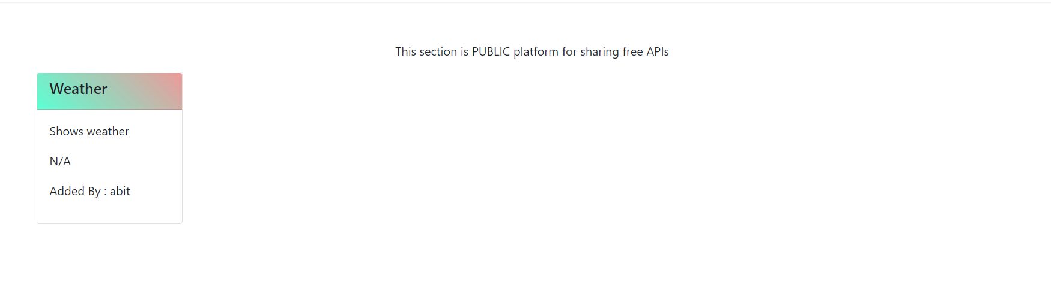

To view API’s added by ADMIN or Developer a user must be signed in

Click on Dashboard and you will be directed to marketplace

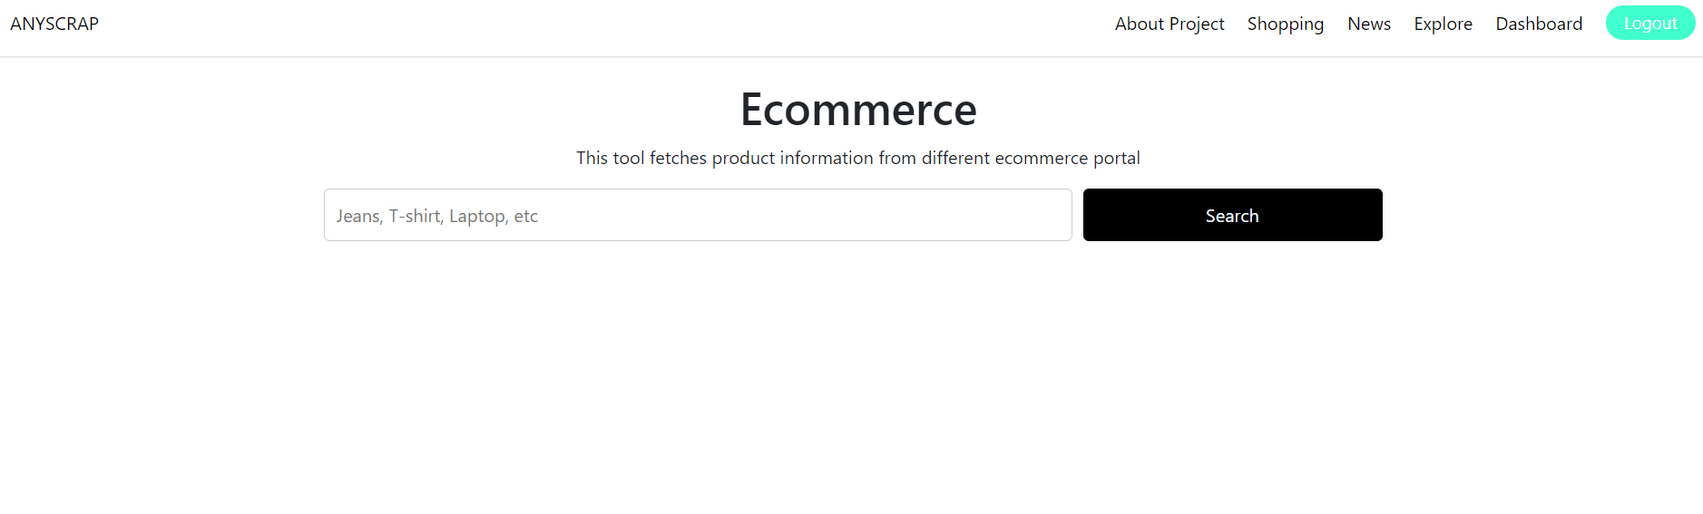

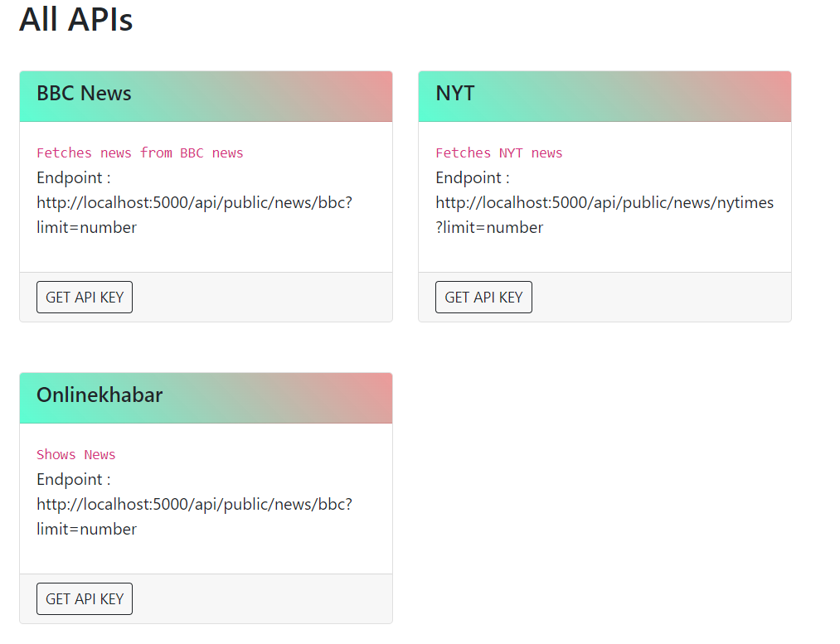

**To get access to available API’s , click on GET API KEY to get the key.**



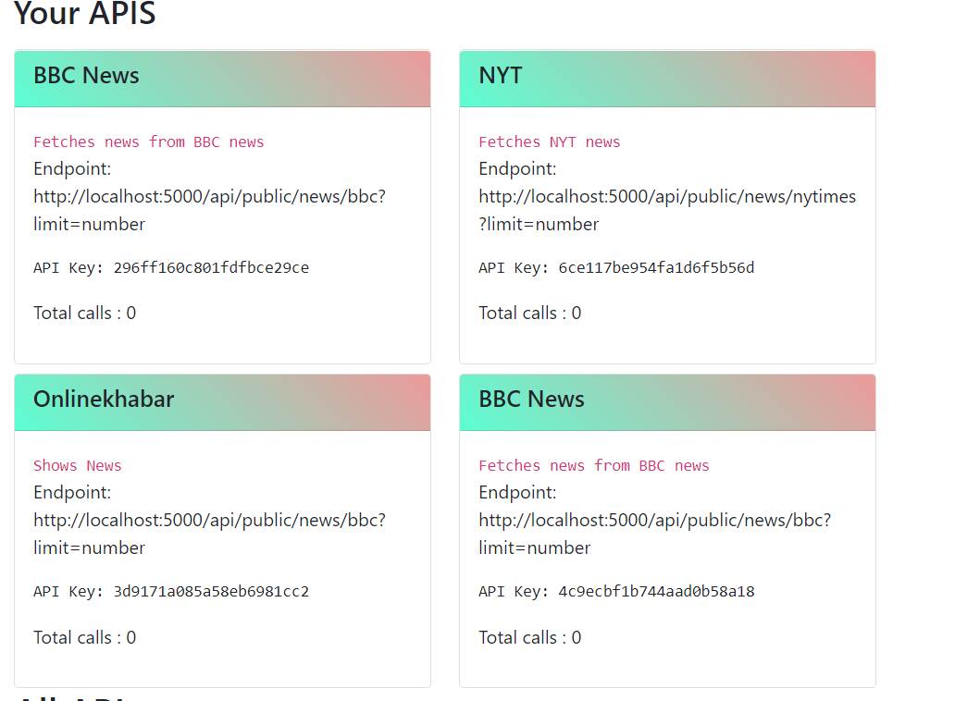

**To contribute any API to anyscrap community, add API description.endpoint and method and click on Add API**

